Practical - 2
Practical Title: Semantic HTML5 Pages with Accessibility-Ready Structure
Problem Definition: Develop static HTML5 skeletons for at least 10 StudentHub pages such as Home, About, Register, Login, Dashboard, Events, Profile, Contact, Admin, FAQ, and Feedback. Use semantic tags and accessibility-friendly structure.
- Theory:
- Are semantic tags such as header, nav, main, section, article, aside, and footer used properly?
Answer: Yes, semantic tags like <header>, <nav>, <main>, <section>, and <footer> are used to organize the webpage and improve readability.
- Are form labels, headings, image alt text, and navigation links accessible?
Answer: Yes, forms use proper labels, headings follow a clear hierarchy, images include alt text, and navigation links are easy to access.
- Is the page structure consistent across all pages?
Answer: Yes, all pages follow the same layout with a common header, navigation bar, main content area, and footer, providing a consistent user experience.
- Implementation/ Output/Result
Indax page:
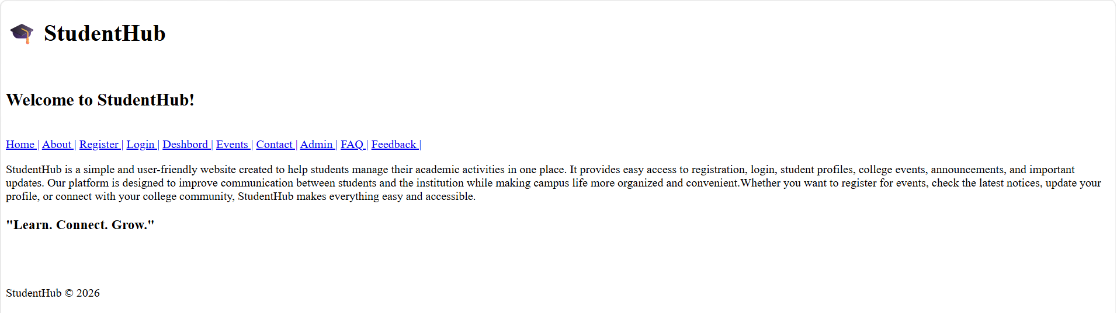
Home page:
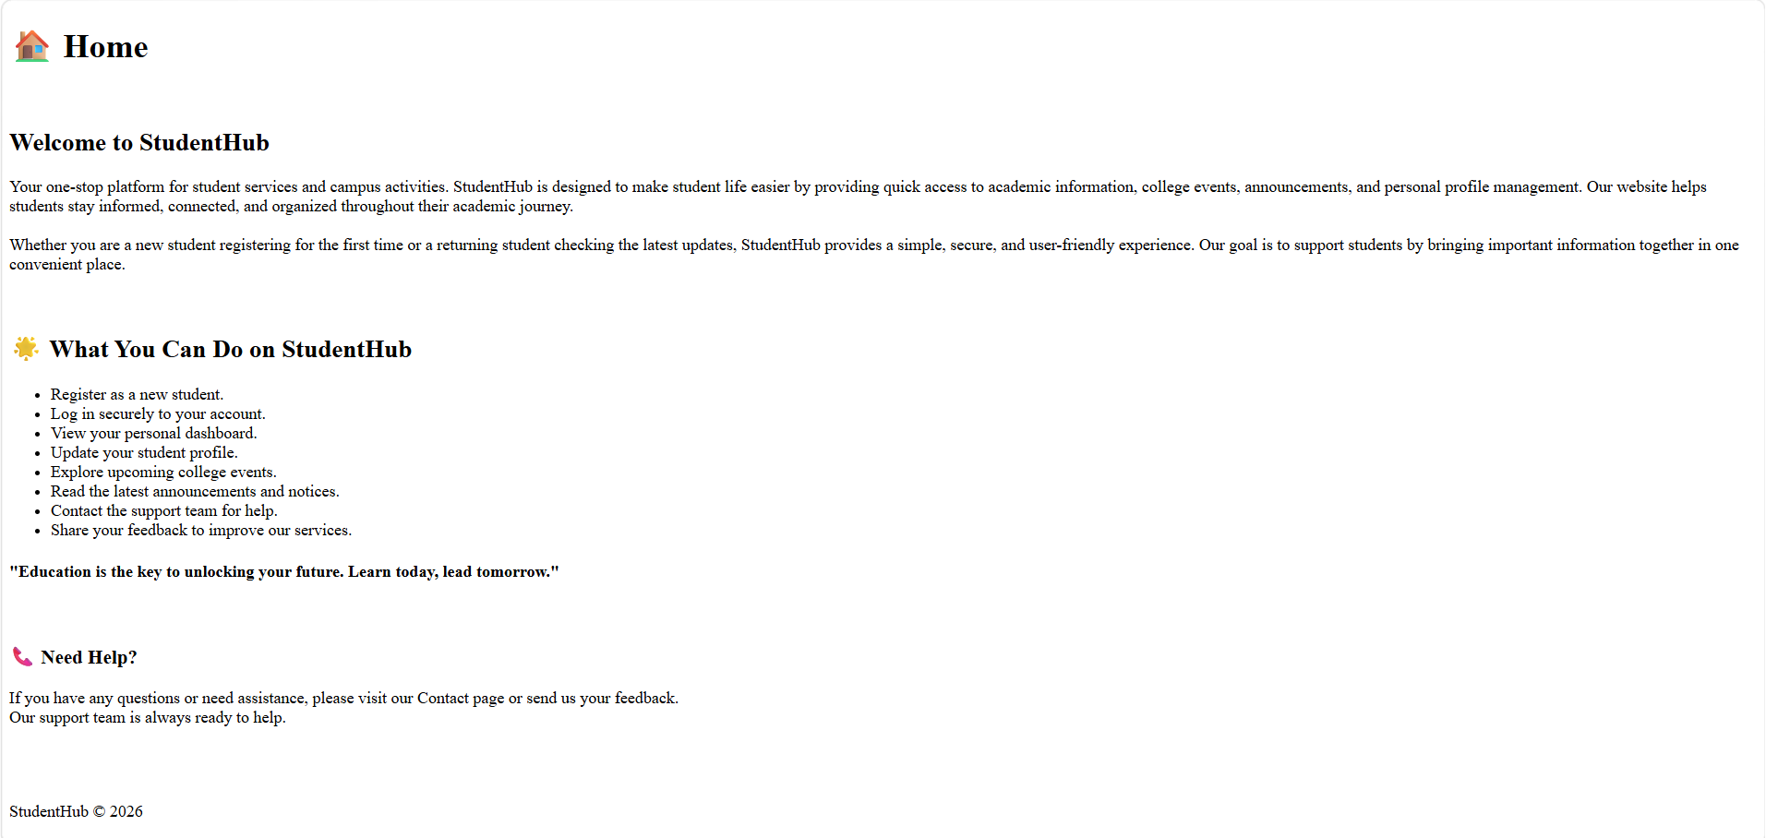
About page:
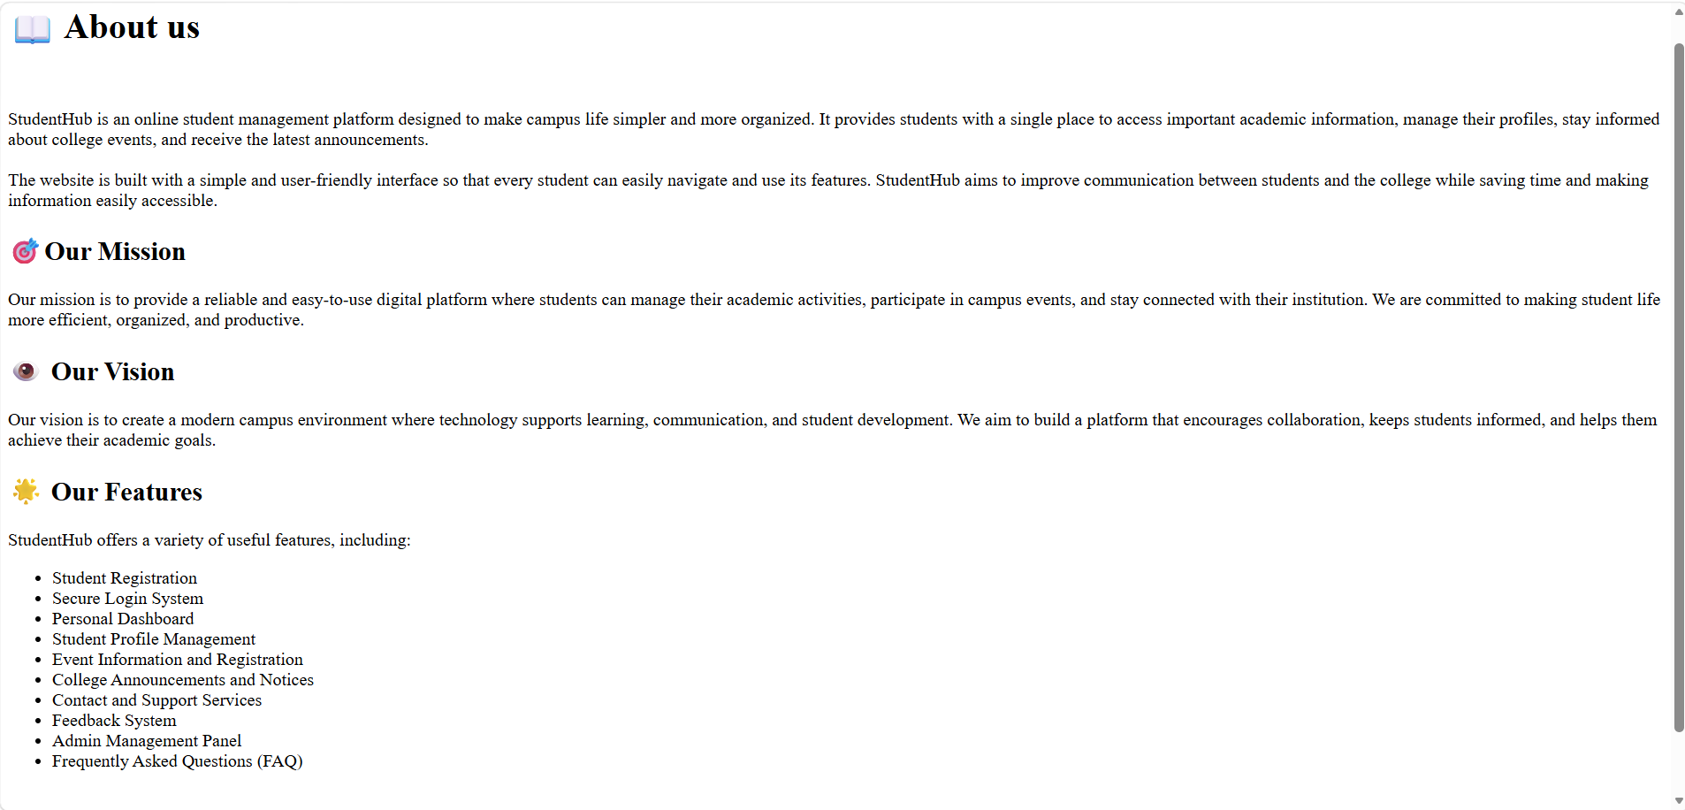
Register page:
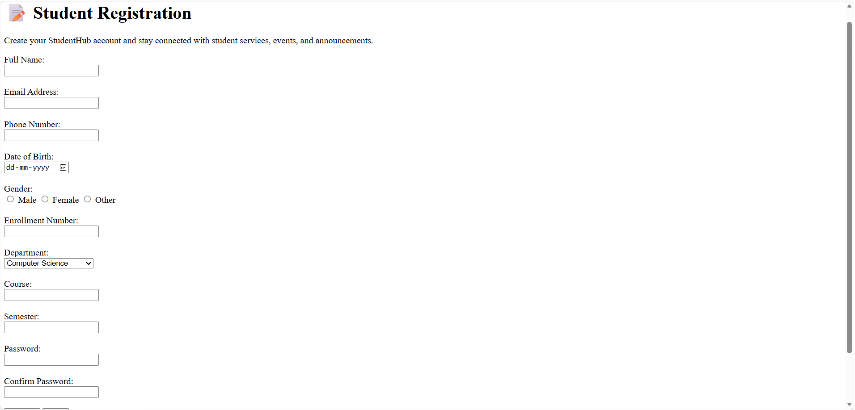
Login page:
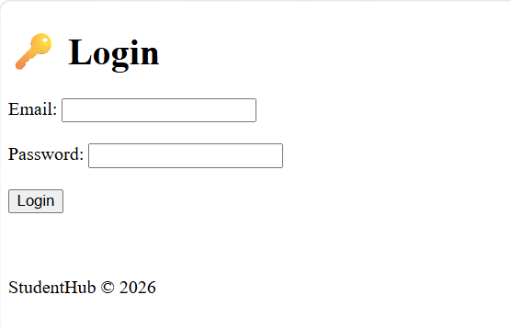
Dashboard page:
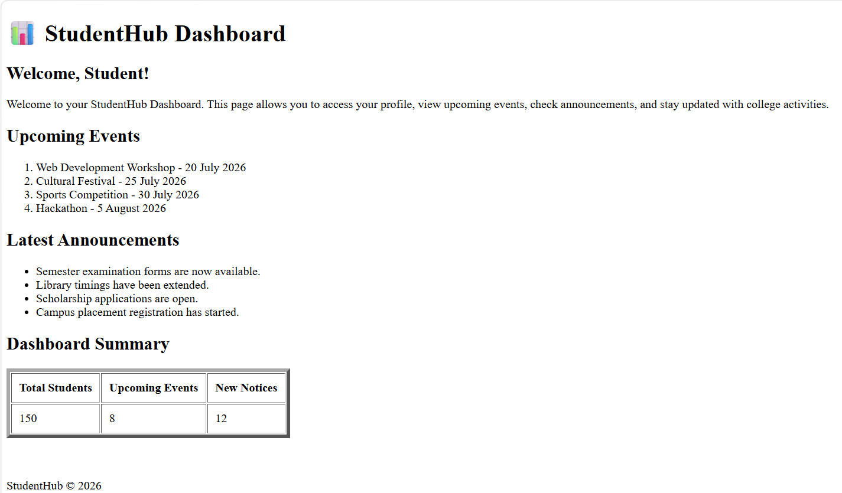
Event page:
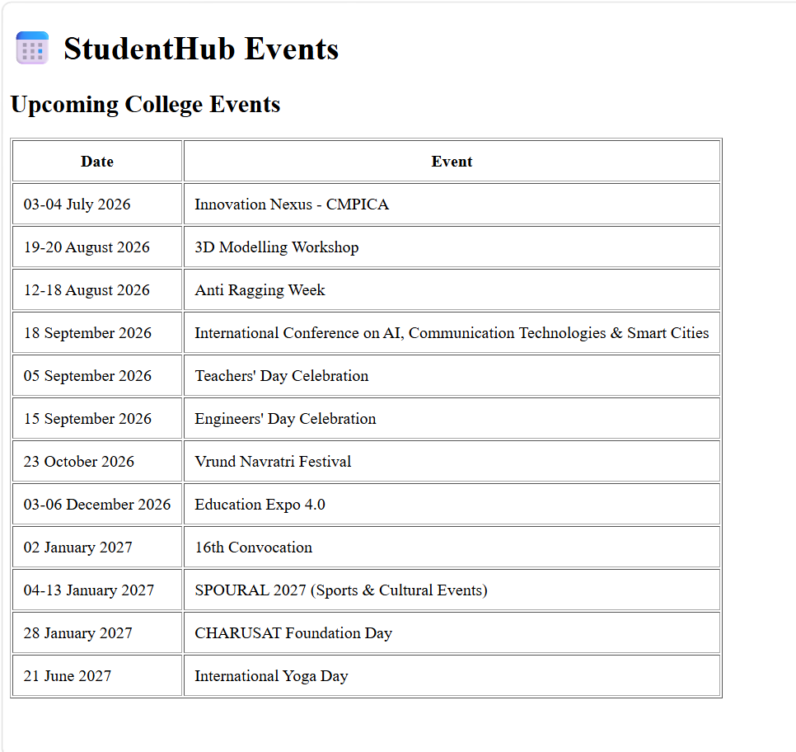
Contact page:
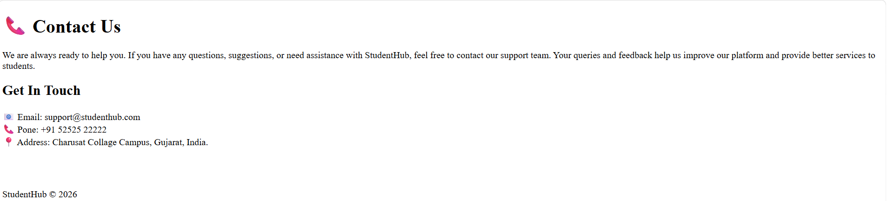
Administrator page:
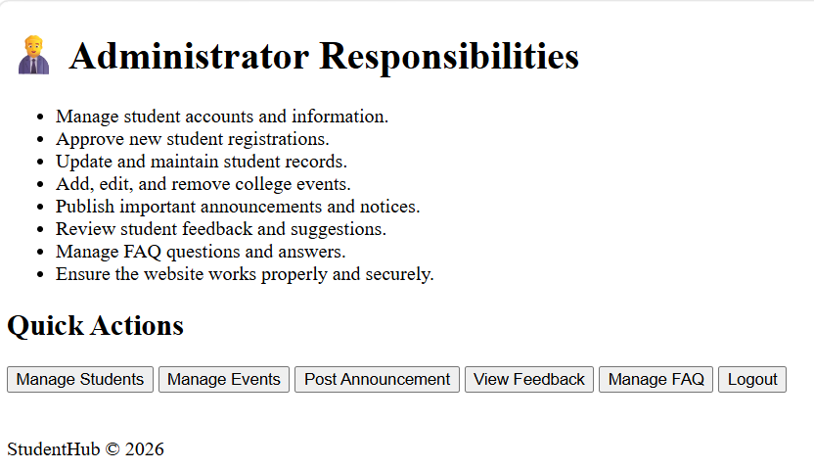
FAQ page:
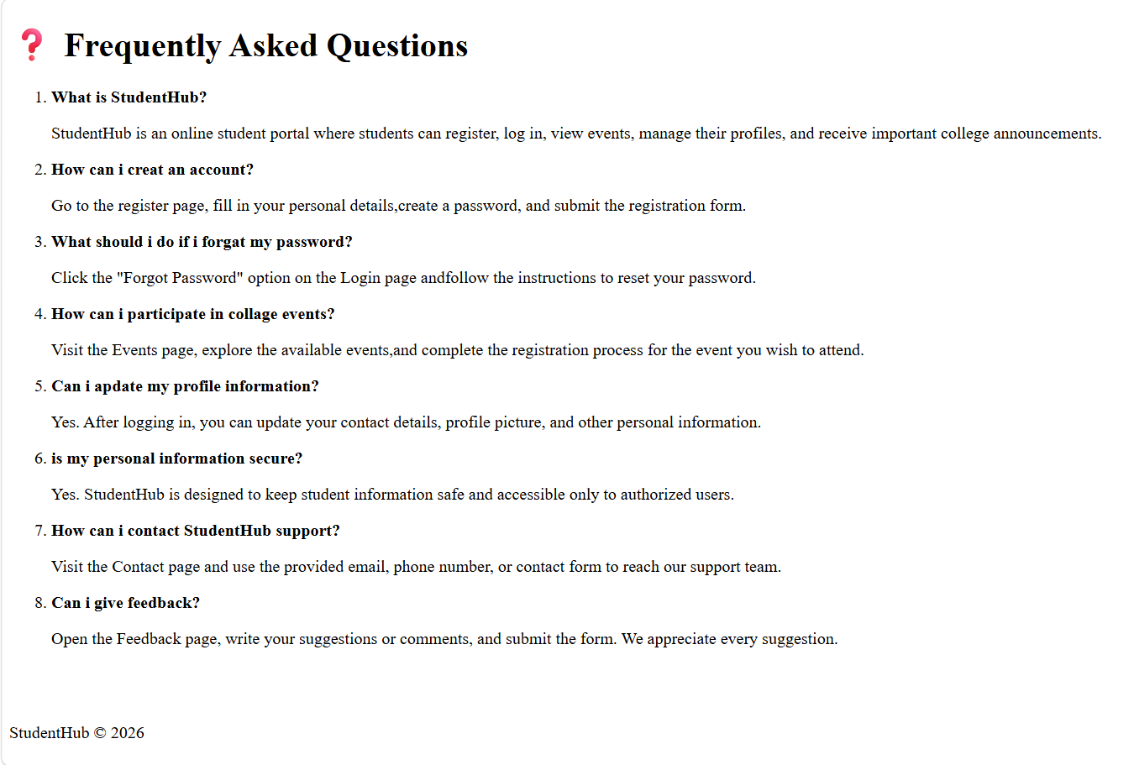
Feedback page:
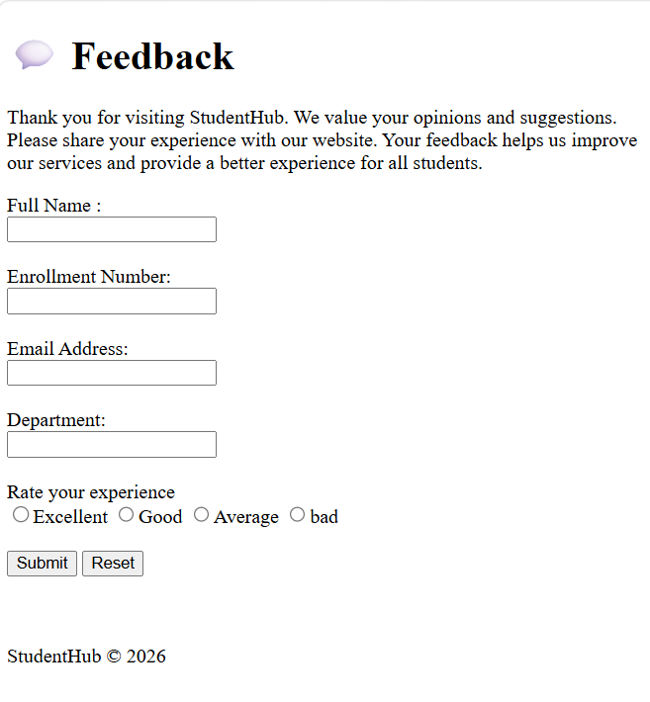
- GitHub Repository Link:
StudentHub/HTML at main · savaliyariya03/StudentHub
- Challenges Faced:
Used semantic HTML tags correctly.
Fixed navigation and page structure issues.
- Learning Outcomes:
Learned semantic HTML5.
Improved webpage structure and accessibility.
Created consistent layouts for multiple pages.
- Faculty Remarks:

